Celicard tablet  Celoprolol ..200mg |  | Pharmaceutical Manufactures India
 | 
Celicard belongs to a group of medicines called beta-blockers, which block receiving bêtas in the heart, of the lungs and other bodies of the body. The blocking of these receivers prevents the action of two chemicals called noradrenalin and the adrenalin which occur naturally in the body. Those are often mentioned because the chemicals of ' combat or flight ' because they are responsible for the reaction of the body to the stressing situations. The blocking of the receiving bêtas in the heart makes more slowly beat the heart and with less force. This means that the pressure to which blood is pumped out of the heart to the remainder of the body is reduced.
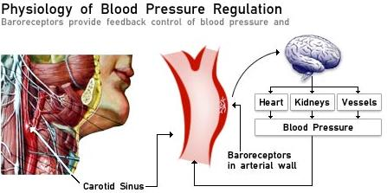
This medicine also widens the arteries. They are two in the manners of which the Celicard assistance to reduce the blood pressure, however the whole mechanism is not entirely included/understood.
Side Effects
* Headache
* nausea,
* dizziness
* abdominal discomfort,
* palpitations,
* Disturbances of the gut such as diarrhoea, constipation, nausea, vomiting or abdominal pain
* sleep difficulties and
* muscle cramps.
Dosage
Always read the layer of the information of the manufacturer, if possible, before beginning the treatment.
Take each amount of half of Celicard at one hour before food. Never take more than the prescribed amount. If you suspect that you or somebody of other took with an overdose of contact of Celicard your doctor or goes to the department of accidents and help of your local hospital immediately.
Warnings and Precautions
This medicine can mask the symptoms of bottom sweetens blood such as the heart rate, the increased tremor and nausea. People with diabetes would have supervise their sugar of blood carefully.
Storage
You should never use any medications after its expiration date, and all medications should be kept out of the reach of children. This medication should be stored in a cool dry place and kept away from heat and light.
